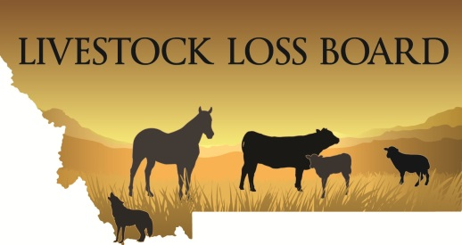 | Montana Livestock Loss Board  PO Box 202005  Helena MT 59620  (406) 444-5609  LIVLossBoard@mt.gov  www.llb.mt.gov

FOR IMMEDIATE RELEASE:
March 5, 2026

CONTACT:
Leslie Doely, MT Dept of Livestock, (406) 444-5609, LDoely@mt.gov
Brian Simonson, MT Dept of Livestock, (406) 444-4994, Brian.Simonson@mt.gov

Montana Livestock Loss Board Announces Livestock Loss Prevention Grant Recipients
HELENA, Mont. – The Montana Livestock Loss Board, an attached agency of the Montana Department of Livestock, is awarding $121,313 to nine projects that intend to proactively implement measures that decrease the risk of wolf, grizzly bear, black bear, and mountain lion predation on livestock.
The Montana Livestock Loss Board was established by the legislature in 2007 to address economic losses due to wolf predation and to create incentives for producers to take proactive, preventative steps to decrease the risk of loss.
The current purpose of the Montana Livestock Loss Program is to acknowledge the importance of economic viability and sustainability for livestock operators who are negatively affected by wolves, grizzly bears, black bears, or mountain lions. Specifically, the purpose of the loss reduction and mitigation programs are:
- To provide financial reimbursements to producers for losses caused by wolves, grizzly bears, black bears, or mountain lions based on program criteria.
- To proactively apply prevention tools and incentives to decrease the risk of wolf, grizzly bear or mountain lion caused losses.
The Livestock Loss Prevention Grant program offers funding in the form of a grant to cost share programs and activities that are based in scientifically proven strategies for mitigating and deterring livestock depredation. Applicants applying for grants are required to provide 30% of the funds required to complete the project, and if awarded, required to provide follow-up reports on the success of their efforts.
2026 Livestock Prevention Grant Award Recipients
Blackfoot Challenge – Ovando
$23,600 grant will be used to procure and construct bear exclusion fencing to prevent conflict between grizzly bears and 400 head of livestock.

Centennial Valley Association– Dell
$20,000 grant to provide for a seasonal range rider and support to protect 3,120 grazing livestock.

Converse Ranch – Augusta
$1661.80 grant to provide for a guard dog and necessary support to protect 169 head of livestock.

Holland Ranch – Dillon
$3117.45 grant to support the use of guard dogs to protect 500 head of livestock.

Bill Martinell – Dell
$1047.87 grant to support the use of guard dogs to protect 997 head of livestock.

Sam Ortmann – Wolf Point
$9869.30 grant to purchase a thermal imaging scope and to support the use of guard dogs to protect 1258 head of livestock.

Pipestone Grazing Association – Whitehall
$17,000 grant to provide three range riders to protect 864 head of grazing livestock.

Rebish/Konen Livestock – Dillon
$20,517 grant to provide for three guard dogs and necessary support to protect 4985 head of grazing livestock.

Ruby Valley Conservation District – Sheridan
$24,500 grant will be dedicated to the operation of a carcass composting facility to remove dead livestock from area ranches comprising 3623 head of livestock and reduce predator conflict.

For more information on the Montana Livestock Loss Board programs and services, visit www.llb.mt.gov.
For more information on the Montana Department of Livestock programs and services please visit https://liv.mt.gov/index.

