This document is designed to guide you through the steps you will take within the State of Montana Talent system as a manager to complete year-end performance evaluations for your employees.

Overall Process:
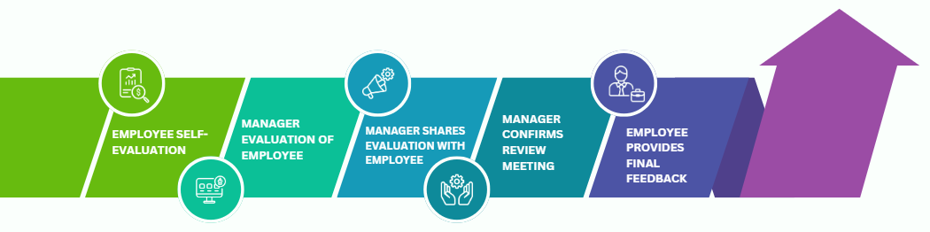

Navigation:
- Login
  - Go to https://sabhrsi.mt.gov/
    - Click on the Talent button under Quick Links
  - Login:
If you are logged in on the State network, click the Company Single Sign-On button
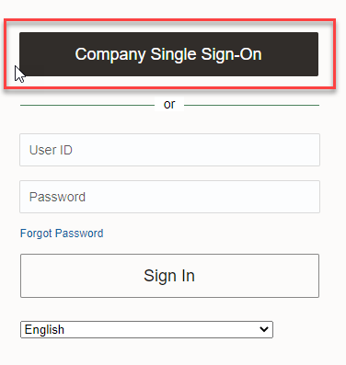
If you are on a mobile device or off the State network, go to sabhrs.mt.gov, click the Talent button under quick links and log in with your username and password:
Username = your employee ID number (6-digit number on your badge, not c#)
Password = if you are a new user OR don’t remember your password, click Forgot Password on the login screen to have an email sent to you with a link to reset your password
*If you are still having trouble logging in, please email talent@mt.gov.

- Click the My Team tab
- Click the Performance icon
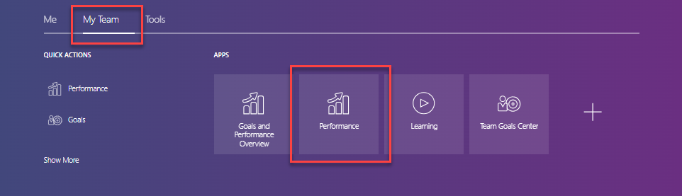

- Click 2024 Employee Year-end Performance Evaluation for the employee you wish to evaluate

Once the employee has completed the self-evaluation, you will receive an email letting you know it is complete. Please note, you may begin the manager evaluation prior to the employee completing the self-evaluation, although you won’t be able to submit the manager evaluation until the employee has submitted the self-evaluation. You are now ready to start the goals section of the evaluation.

Review employee goals:
In this section, you will comment on the progress of each goal from the 2024 goal plan.
NOTE: If you would like to add, edit, or update any of the goals for the 2024 goal plan, click the Review employee goals image.
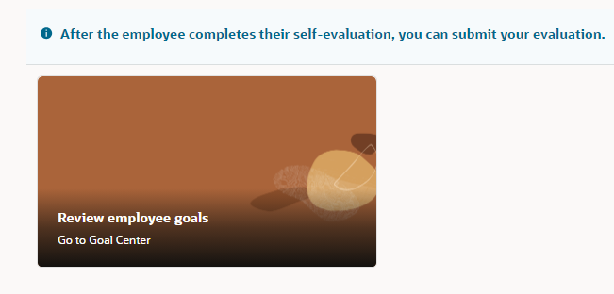

  - To add a goal, click the +Add button - *Required field: What’s your goal? – Click Add
  - To edit an existing goal, click the goal name, then click Edit Goal, Update
  - To update progress, click the goal name and use the Goal Completion progress bar. You may enter comments. Click Update to save your goal progress.
  - To return to the performance document click the back arrow next to your employee’s initials

Goal Plan Section:
- Click a goal to expand it and reveal the Manager Comments Textbox
- Enter your Manager Comments in the textbox
  - If you do not see the Employee comments, they have not submitted their self-evaluation
- Once you’ve commented, click Save and Next to go to the next goal in the list.
  - If you wish to not include a goal on the performance document, click the toggle button – Not ready for evaluation
    - You will still be able to see and comment on this goal

- When you have commented on the last goal, click Save and Close.
- Once you’ve commented on each goal, scroll down to the Employee Competencies Section

*Optional* Review Check-Ins:
- Click the Show Other Info – this is located under Competencies
- Quarterly Check-Ins will be displayed on a pop-up window for your review. Click on the Check-Ins document you would like to review

Competency Section:
In this section you will select a rating and comment on each competency.

- Click on a competency name
- Review the employee’s rating and comments (comments located below the Manager Comments textbox) on each competency.
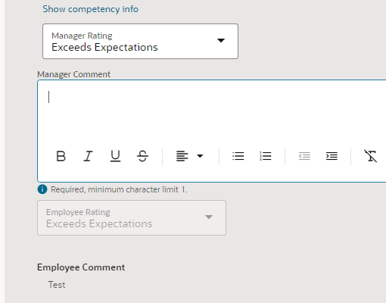
- Select a rating for the employee in the Manager Rating dropdown and enter your comments regarding the employee’s performance in relation to each competency in the Manager Comments textbox.
  - Click the Show competency info link to display the rating definition and ensure you understand the intent of each rating level.
- Once you have selected a rating and entered a comment, click Save and Next to go to the next competency in the list.
- When you have commented on the last competency, click Save and Close.
- When you are satisfied with the evaluation, click Submit at the top of the Manager Evaluation page.

At this point, the employee still cannot see your comments and ratings, if you need an upper-level manager or HR to review prior to releasing to the employee, they now have access to view what you have submitted. Once you are ready to share the evaluation with the employee, move to the next step, Share Performance Document.
If you want to verify that the self-evaluation was shared to the employee, go to My Team>Performance> Scroll to the Employee Year-end Performance Evaluation for the employee you wish to review
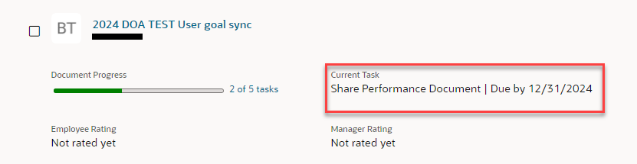

Manager Shares Performance Document with Employee
In this section you will share the completed evaluation with the employee.
- From the home page, click My Team
- Click Performance
- Click 2024 Employee Performance Evaluation next to employee’s name
- Click Share and Release*

*If you click Share and Retain, you will not be able to continue to the next step until you click Share and Release.

The employee will now receive an email letting them know that the evaluation is ready for their review. This is a good time to schedule the review meeting if you have not done so already. After the review meeting is held, continue to the next step, Confirm Review Meeting.

Manager Confirms Review Meeting
You will complete this section after the review meeting has been held. This step records the date of the review meeting.
- From the home page, click My Team
- Click Performance
- Click 2023 Year-end Performance Evaluation next to employee’s name
- Select the date you held the review meeting
- Add comments
- Click Confirm

Congratulations! You have completed the manager portion of the performance evaluation. The employee will now receive an email notifying them to confirm the review meeting date and to provide final feedback.

Be sure to work with your employees to set goals for 2025. For more help with this, see Goal Management for Managers.

