This document is designed to guide you through the steps you will take within the State of Montana Talent system as an employee to complete the year-end performance evaluation.

Overall Process:
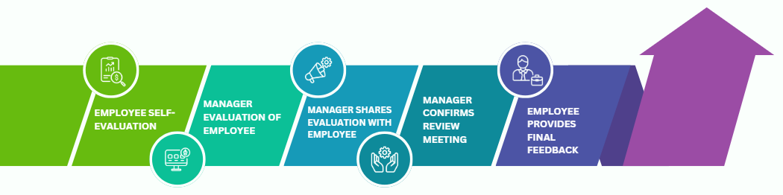
Navigation:
- Login
  - Go to https://sabhrsi.mt.gov/
  - Click on the Talent button under Quick Links
  - Login:
    - If you are logged in on the State network, click the Company Single Sign-On button
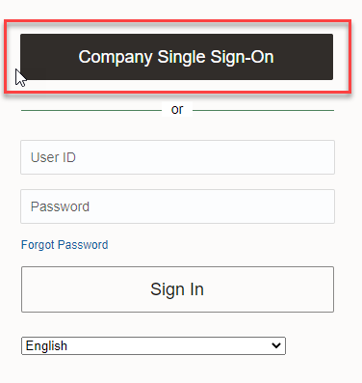

    - If you are on a mobile device or off the State network, go to https://sabhrs.mt.gov/, click the Talent button under Quick Links and log in with your username and password:
- Username = your employee ID number (6-digit number on your badge, not c#)
- Password = if you are a new user OR don’t remember your password, click Forgot Password on the login screen to have an email sent to you with a link to reset your password

*If you are still having trouble logging in, please email talent@mt.gov.

- From the Me tab, click the Career and Performance icon
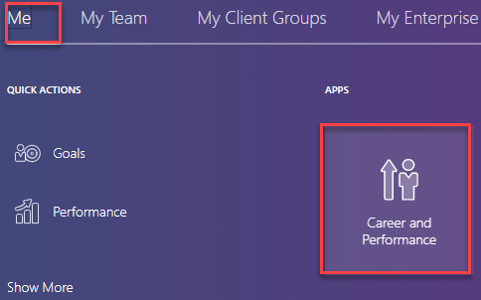

- Under Current Task, click on Worker Self-Evaluation.
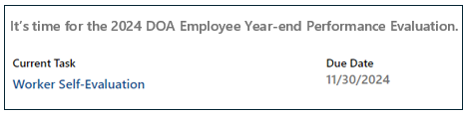
- If you don’t see Worker Self-Evaluation under Current Task, you may also click the Performance box, then click on the Performance Documents tab.

Goal Plan Section:
In this section you will comment on the progress of each goal you entered in the current goal plan. If you would like to add, edit, or update your goal completion progress, please refer to the *Optional Adding, editing, or updating a goal instruction below.

*Optional* Adding, editing, or updating a goal:
- Click the Update your goals image at the top of the page

  - To add a goal, click the +Add button - *Required field: What’s your goal? – Click Add
  - To edit an existing goal, click the goal name, then click Edit Goal, Update
  - To update your progress, use the Goal Completion progress bar to indicate your goal completed percentage. You may enter comments. Click Update to save your goal progress.
  - To return to the performance document, click the back arrow next to your initials

Enter Goal Comments:
- Click on a goal name to add comments
- Enter your comments in the Employee Comment textbox
  - If you do not want to include a goal on your performance document, click the toggle button Not ready for evaluation
    - Your manager will still be able to see and comment on this goal

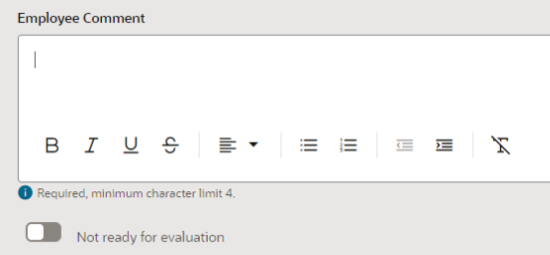
- Once you’ve commented, click Save and Next to go to the next goal in your list.
- When you have commented on your last goal, click Save and Close.

You are now ready to move to the competencies section. If you would like to review your Quarterly Check-ins to assist you with completing the competency section, please refer to the Review Check-in procedure below.

*Optional* Review Check-Ins:
- Click the Show Other Info – this is located under the Competencies section
- Your Quarterly Check-Ins will be displayed on a pop-up window for your review. Click on the Check-Ins document you would like to review

Competency Section:
In this section you will rate and comment on each competency.

- Click on a competency name
- Enter your Employee Rating and Employee Comments regarding your performance in relation to each competency.
  - Click the Show competency info link to display the rating definition and ensure you understand the intent of each rating level.
- Once you have selected a rating and entered a comment, click Save and Next to go to the next competency in your list.
- When you have commented on the last competency, click Save and Close.
- When you are satisfied with the evaluation and ready for your manager to review click Submit at the top of the Worker Self Evaluation page

Once you submit:
- Your manager will receive an email letting them know your self-evaluation is complete and ready for review.
- Your manager will complete his/her review and then share the document with you. You will receive an email letting you know the evaluation is ready for review.
- You may click the link in the email or in Talent navigate to Me > Career and Performance > Performance > Performance Documents tab.
You should review your manager’s competency ratings and comments and prepare to discuss the evaluation at the review meeting. Your manager will schedule a review meeting to discuss the evaluation and once that meeting has been held, your manager will enter the date of the meeting, and you will receive an email to provide any final feedback and signoff that you reviewed the evaluation.

Provide Final Feedback
You will complete this section after the review meeting is held. In this section you may enter any final feedback comments you may have in reference to the performance review and provide signoff that you’ve reviewed the evaluation.

- From the Talent home page, Me - Career and Performance icon
- Under Current Task click Provide Final Feedback
- *Optional* enter feedback comments in response to the performance evaluation
- Click the checkbox at the bottom to verify your identity

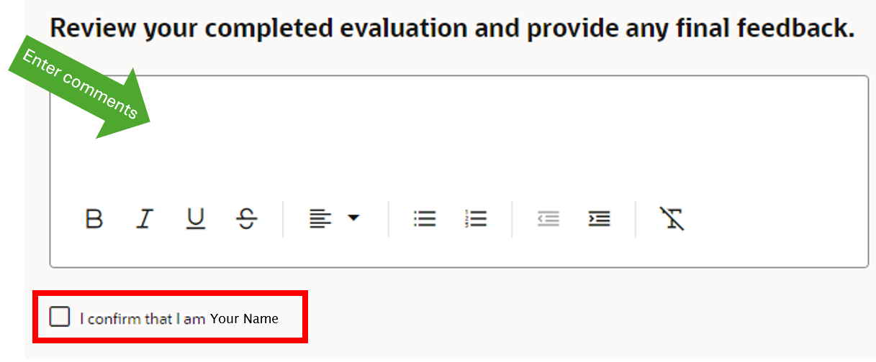

- Click Submit

Congratulations! You have completed the performance evaluation; you may log back in at any time to review the completed evaluation.

Be sure to set your goals for 2025. To do this, go to Career and Performance>Goal Center, for assistance, see Goal Management for Employees.

