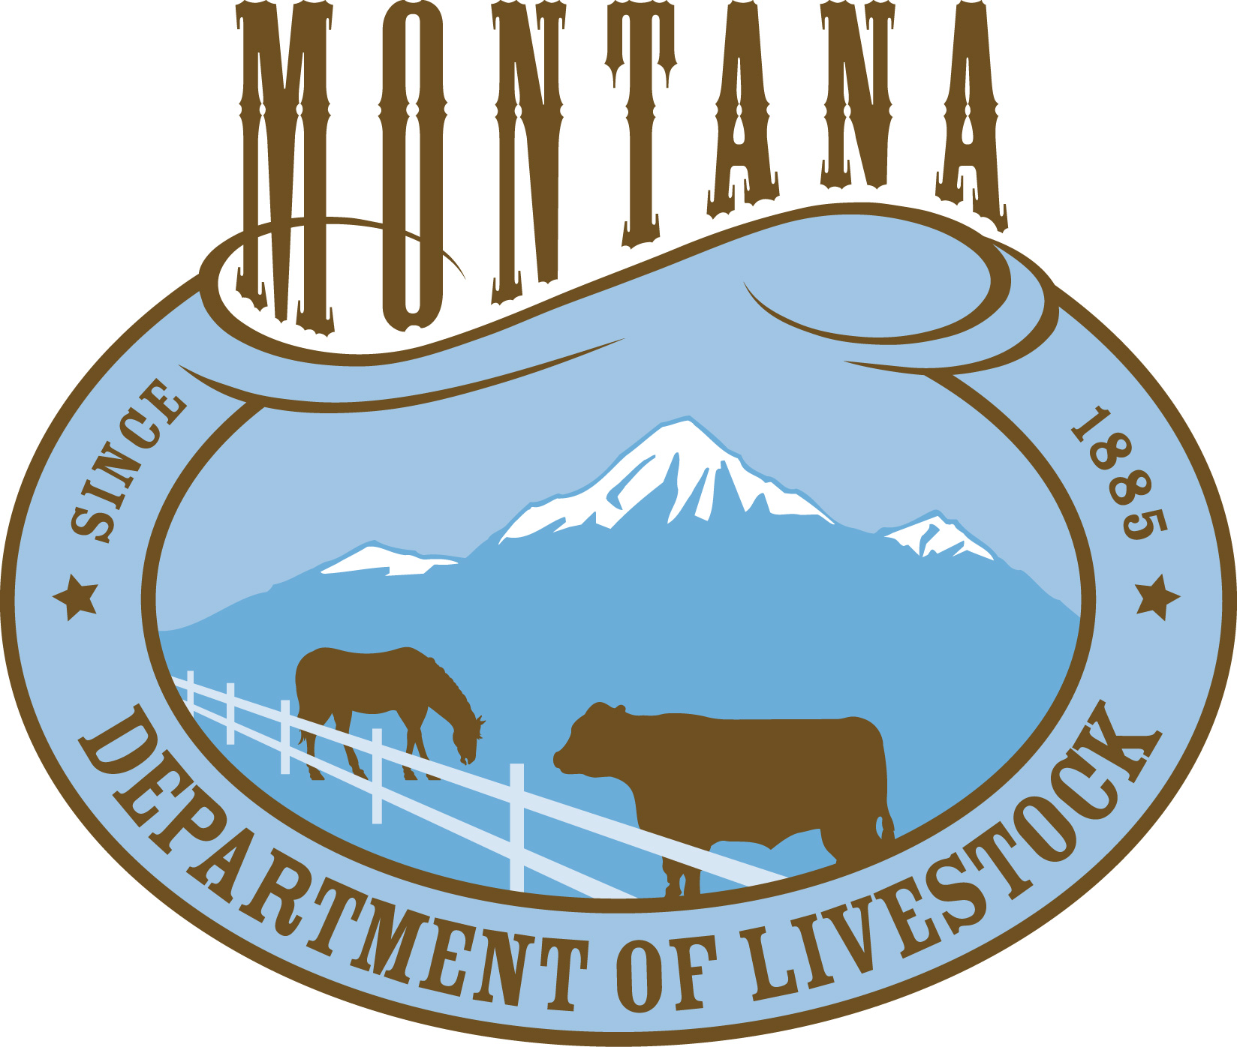

EQUAL EMPLOYMENT OPPORTUNITY POLICY STATEMENT

It is the policy of the Department of Livestock, State of Montana, to provide
equal employment opportunity (EEO) to all persons regardless of race, color, religion, creed, sex, national origin, age, mental or physical disability, marital status, or political belief with the exception of special programs established by law.

The Department of Livestock will take affirmative action (AA) to equalize employment opportunities at all levels of department operations where there is evidence that there have been barriers to employment for those classes of people who have traditionally been denied equal employment opportunity.

The Department of Livestock makes a commitment to provide reasonable accommodation to any known disability that may interfere with an applicant's ability to compete in the selection process or an employee's ability to perform the duties of the job.

The Department of Livestock guarantees employee protection against retaliation for lawfully opposing any discriminatory practice, including the filing of an internal grievance alleging unlawful discrimination, the filing of a union grievance, the initiation of an external administrative or legal proceeding or testifying in or participating in any of the above.

The designated EEO Officer for the Department of Livestock is the current Personnel Officer. This person is responsible for coordinating the department's EEO/AA program and for resolving applicant/employee EEO complaints. The Personnel Office is Room #309 and the phone number is 444-5684.

_____________________________________ _____________________________
Executive Officer Date
Department of Livestock

